Maths Workshop For Parents

Year 2 Learning Objectives

Number – Number and Place Value
- count in steps of 2, 3, and 5 from 0, and in tens from any number, forward and backward
- recognise the place value of each digit in a two-digit number (tens, ones)
- identify, represent and estimate numbers using different representations, including the number line
- compare and order numbers from 0 up to 100; use <, > and = signs ▪ read and write numbers to at least 100 in numerals and in words
- use place value and number facts to solve problems.
Number – Addition and Subtraction
- solve problems with addition and subtraction:
- using concrete objects and pictorial representations, including those involving numbers, quantities and measures
- applying their increasing knowledge of mental and written methods
- recall and use addition and subtraction facts to 20 fluently, and derive and use related facts up to 100
- add and subtract numbers using concrete objects, pictorial representations, and mentally, including:
- a two-digit number and ones
- a two-digit number and tens
- two two-digit numbers
- adding three one-digit numbers
- show that addition of two numbers can be done in any order (commutative) and subtraction of one number from another cannot
- recognise and use the inverse relationship between addition and subtraction and use this to check calculations and solve missing number problems.
Number – Multiplication and Division
- recall and use multiplication and division facts for the 2, 5 and 10 multiplication tables, including recognising odd and even numbers
- calculate mathematical statements for multiplication and division within the multiplication tables and write them using the multiplication (×), division (÷) and equals (=) signs
- show that multiplication of two numbers can be done in any order (commutative) and division of one number by another cannot
- solve problems involving multiplication and division, using materials, arrays, repeated addition, mental methods, and multiplication and division facts, including problems in contexts.
Number - Fractions
- recognise, find, name and write fractions 1/3,1/4,2/4 and 3/4 of a length, shape, set of objects or quantity
- write simple fractions for example, 1/2 of 6 = 3 and recognise the equivalence of 2/4 and 1/2.
Measurement
- choose and use appropriate standard units to estimate and measure length/height in any direction (m/cm); mass (kg/g); temperature (°C); capacity (litres/ml) to the nearest appropriate unit, using rulers, scales, thermometers and measuring vessels
- compare and order lengths, mass, volume/capacity and record the results using >, < and =
- recognise and use symbols for pounds (£) and pence (p); combine amounts to make a particular value
- find different combinations of coins that equal the same amounts of money
- solve simple problems in a practical context involving addition and subtraction of money of the same unit, including giving change
- compare and sequence intervals of time
- tell and write the time to five minutes, including quarter past/to the hour and draw the hands on a clock face to show these times
- know the number of minutes in an hour and the number of hours in a day.
Geometry – Properties of Shapes
- identify and describe the properties of 2-D shapes, including the number of sides and line symmetry in a vertical line
- identify and describe the properties of 3-D shapes, including the number of edges, vertices and faces
- identify 2-D shapes on the surface of 3-D shapes, [for example, a circle on a cylinder and a triangle on a pyramid]
- compare and sort common 2-D and 3-D shapes and everyday objects.
Geometry – Position and Direction
- order and arrange combinations of mathematical objects in patterns and sequences
- use mathematical vocabulary to describe position, direction and movement, including movement in a straight line and distinguishing between rotation as a turn and in terms of right angles for quarter, half and three-quarter turns (clockwise and anticlockwise).
Statistics
- interpret and construct simple pictograms, tally charts, block diagrams and simple tables
- ask and answer simple questions by counting the number of objects in each category and sorting the categories by quantity
- ask and answer questions about totalling and comparing categorical data.

The National Curriculum for Mathematics aims to ensure that all pupils:

- become fluent in the fundamentals of mathematics, including through varied and frequent practice with increasingly complex problems over time, so that pupils develop conceptual understanding and the ability to recall and apply knowledge rapidly and accurately
- reason mathematically by following a line of enquiry, conjecturing relationships and generalisations, and developing an argument, justification or proof using mathematical language
- can solve problems by applying their mathematics to a variety of routine and non-routine problems with increasing sophistication, including breaking down problems into a series of simpler steps and persevering in seeking solutions

What is ‘Maths Mastery’?

- An approach to teaching and learning, not a level of attainment.
- The belief that all pupils can achieve age-appropriate targets.
- The development of deep mathematical understanding.
- The development of both factual/procedural fluency (knowing how to do the calculation) and conceptual fluency (knowing why the numbers behave the way they do in the calculation).
- Longer time spent on key topics, providing time to go deeper and embed learning rather than moving on to concepts in the next year group.
- Loosely based on the Shanghai / Singapore style of teaching of mathematics (two of the highest performing regions in mathematics).
- A style of teaching that the Government is supporting.
- An overall aim that children are able to use and apply their knowledge in a variety of ways, demonstrating a real depth of understanding.
- Mastery means that learning is sufficiently embedded, deep, connected and fluent in order for it to be sustained, built upon and connected

Supporting your child

- Repetition of procedures
- Explanation of procedures – maths talk in full sentences
- Reasoning EG- prove it … what if … always, sometimes, never true…
- Practical maths to apply understanding
- Fluency of maths facts- counting, number bonds, timestables and related division facts, equivalent FDPs,
- Representing answers in a variety of ways
- Use of correct vocabulary and terminology
- http://amathsdictionaryforkids.com/dictionary.html
- Use of Education City

Year 2 Examples of Fluency, Reasoning and Problem Solving

Fluency:

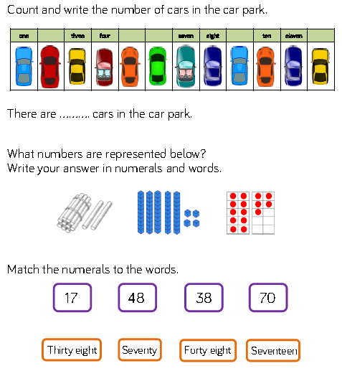

Reasoning: Problem Solving:
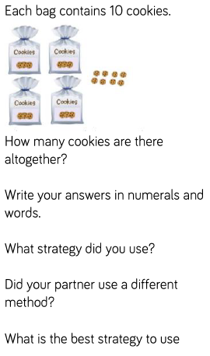
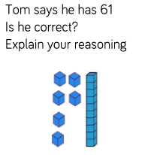

Supporting your child

- Repetition of procedures
- Explanation of procedures – maths talk in full sentences
- Reasoning EG- prove it … what if … always, sometimes, never true…
- Practical maths to apply understanding
- Fluency of maths facts- counting, number bonds, timestables and related division facts, equivalent FDPs,
- Representing answers in a variety of ways
- Use of correct vocabulary and terminology
- http://amathsdictionaryforkids.com/dictionary.html
- Use of Education

