Maths Workshop For Parents

Year 1 Learning Objectives

Number – Number and Place Value
- count to and across 100, forwards and backwards, beginning with 0 or 1, or from any given number
- count, read and write numbers to 100 in numerals; count in multiples of twos, fives and tens
- given a number, identify one more and one less
- identify and represent numbers using objects and pictorial representations including the number line, and use the language of: equal to, more than, less than (fewer), most, least
- read and write numbers from 1 to 20 in numerals and words.
Number – Addition and Subtraction
- read, write and interpret mathematical statements involving addition (+), subtraction (–) and equals (=) signs
- represent and use number bonds and related subtraction facts within 20
- add and subtract one-digit and two-digit numbers to 20, including zero
- solve one-step problems that involve addition and subtraction, using concrete objects and pictorial representations, and missing number problems such as 7 = – 9.
Number – Multiplication and Division
- solve one-step problems involving multiplication and division, by calculating the answer using concrete objects, pictorial representations and arrays with the support of the teacher.
Number - Fractions
- recognise, find and name a half as one of two equal parts of an object, shape or quantity
- recognise, find and name a quarter as one of four equal parts of an object, shape or quantity.
Measurement
- compare, describe and solve practical problems for:
- lengths and heights [for example, long/short, longer/shorter, tall/short, double/half]
- mass/weight [for example, heavy/light, heavier than, lighter than]
- capacity and volume [for example, full/empty, more than, less than, half, half full, quarter]
- time [for example, quicker, slower, earlier, later]
- measure and begin to record the following:
- lengths and heights
- mass/weight
- capacity and volume
- time (hours, minutes, seconds)
- recognise and know the value of different denominations of coins and notes
- sequence events in chronological order using language [for example, before and after, next, first, today, yesterday, tomorrow, morning, afternoon and evening]
- recognise and use language relating to dates, including days of the week, weeks, months and years
- tell the time to the hour and half past the hour and draw the hands on a clock face to show these times.
Geometry – Properties of Shapes
- recognise and name common 2-D and 3-D shapes, including:
- 2-D shapes [for example, rectangles (including squares), circles and triangles]
- 3-D shapes [for example, cuboids (including cubes), pyramids and spheres].
Geometry – Position and Direction
- describe position, direction and movement, including whole, half, quarter and three-quarter turns.

The National Curriculum for Mathematics aims to ensure that all pupils:

- become fluent in the fundamentals of mathematics, including through varied and frequent practice with increasingly complex problems over time, so that pupils develop conceptual understanding and the ability to recall and apply knowledge rapidly and accurately
- reason mathematically by following a line of enquiry, conjecturing relationships and generalisations, and developing an argument, justification or proof using mathematical language
- can solve problems by applying their mathematics to a variety of routine and non-routine problems with increasing sophistication, including breaking down problems into a series of simpler steps and persevering in seeking solutions

What is ‘Maths Mastery’?

- An approach to teaching and learning, not a level of attainment.
- The belief that all pupils can achieve age-appropriate targets.
- The development of deep mathematical understanding.
- The development of both factual/procedural fluency (knowing how to do the calculation) and conceptual fluency (knowing why the numbers behave the way they do in the calculation).
- Longer time spent on key topics, providing time to go deeper and embed learning rather than moving on to concepts in the next year group.
- Loosely based on the Shanghai / Singapore style of teaching of mathematics (two of the highest performing regions in mathematics).
- A style of teaching that the Government is supporting.
- An overall aim that children are able to use and apply their knowledge in a variety of ways, demonstrating a real depth of understanding.
- Mastery means that learning is sufficiently embedded, deep, connected and fluent in order for it to be sustained, built upon and connected to.

Year 1 Examples
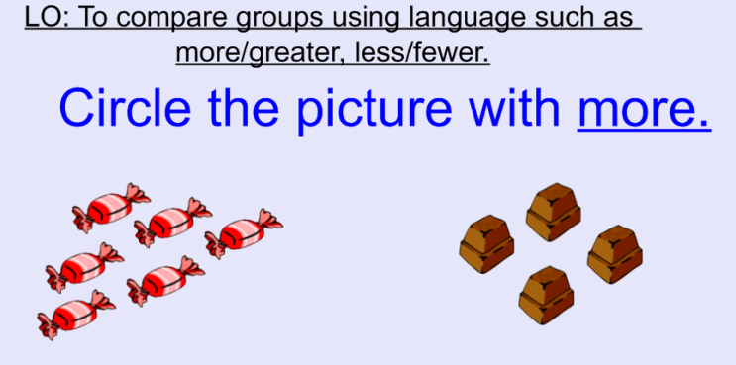
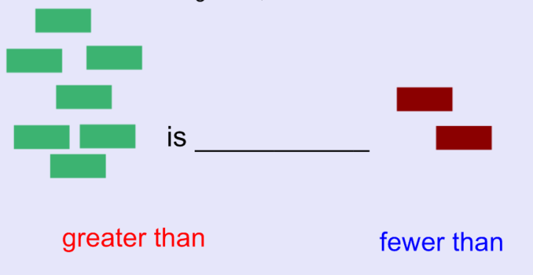

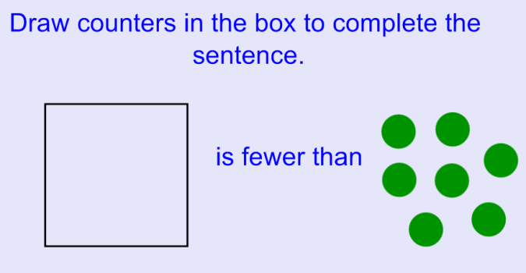
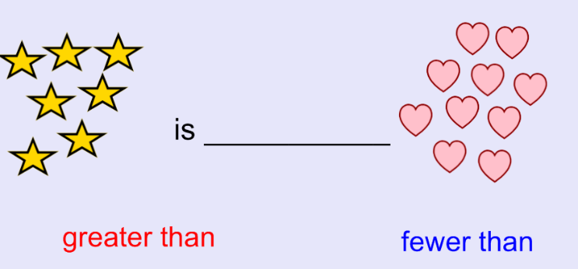

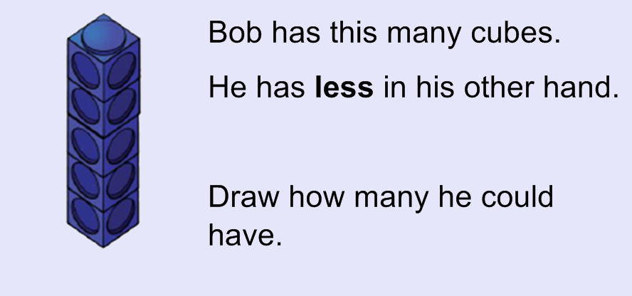
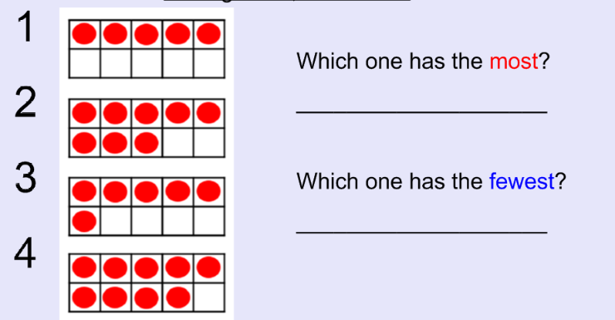

Supporting your child

- Repetition of procedures
- Explanation of procedures – maths talk in full sentences
- Reasoning EG- prove it … what if … always, sometimes, never true…
- Practical maths to apply understanding
- Fluency of maths facts- counting, number bonds, timestables and related division facts, equivalent FDPs,
- Representing answers in a variety of ways
- Use of correct vocabulary and terminology
- http://amathsdictionaryforkids.com/dictionary.html
- Use of Education City

